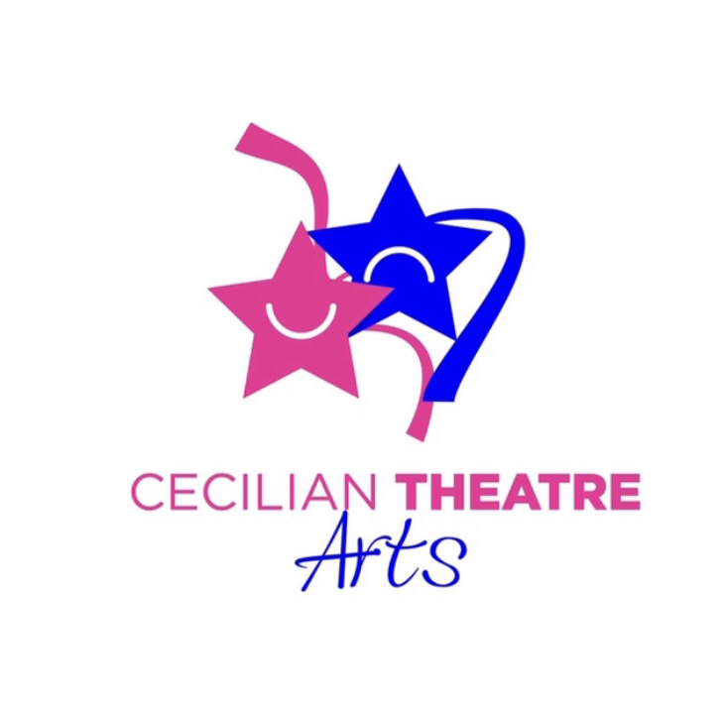
CECILIAN THEATRE ARTS

CHILD PROTECTION POLICY STATEMENT

We Cecilian Theatre Arts (Drama, Dance, Singing) are committed to a child-centred approach to our work with children and young people. We undertake to provide a safe encouraging environment and experience, where the welfare of the child/young person is paramount. We adhere to the recommendations of Children First: National Guidelines for the Protection and Welfare of Children, published by the Department of Health and Children, Tulsa, the Guidelines for the Protection and Welfare of Children and Young People in the Arts Sector, published by the Arts Council, and the “Codes for Professional Conduct for Teachers” published by the Teaching Council. We have carried out a full risk assessment and are committed to renewing/updating our policy & certificate every two years.

Designated Liaison: Jennifer O’Dowd
Designated Liaison: Rosalind O’Dowd

OUR FULL CHILD PROTECTION POLICY IS AVAILABLE ON REQUEST FOR PARENTS

UPDATED: MARCH 2021

