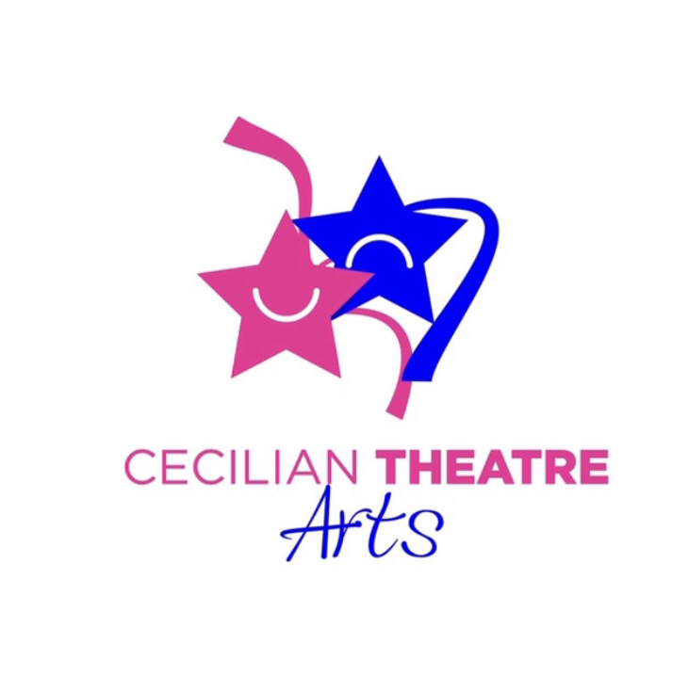
COVID 19 UPDATES
TERMS & CONDITIONS FOR SUMMER CAMPS /MASTERCLASSES

For the purpose of this document
“WE”means: Cecilian Theatre Arts

- Parents/Guardian must ensure that students have the following items in a small bag that they can access, open & close by themselves. (The Community Centre shop will not be open to students)
- 1 Lunch (Yogurts /Popcorn/Nuts/Whole Apples are disallowed)
- 1 Drink
- 1 Small bottle of hand sanitizer
- 1 Pack of tissues
(Please note; no folders for Junior Students only. Toys & all other unnecessary items disallowed)

- Students must wear:
- T-Shirt / Jumper
- Leggings/Tracksuit Bottoms
- Raincoat
- Cap/hat
- Runners (Dresses/Skirts/ Boots are strictly disallowed for safety reasons)
- Sun cream must be applied at home prior to attending camp

- DROP OFF:
Parents/Guardians to ensure children’s hands are washed & then sanitized (Sanitization is not as effective on dirty hands). The bathrooms will not be accessible before camp, so please do not enter the building. We must respect the rules of the centre. Temperature must be taken by parents/guardian just prior to entry to ensure it presents as normal, we will also be doing intermittent temperature checks. All students must sanitise hands on entry & also MUST have a small bottle of hand sanitiser which they will use before the break and just before leaving. There are no hand sanitising machines in the room & unfortunately staff must keep their distance from students. So it is essential that every child has their own. It is Parent/Gaurdians responsibility to inform us if their child has any allergies to hand sanitizers. If children are showing symptoms of being unwell or presents with a temperature Cecilian Theatre Arts holds the right to refuse entry to camp. All students to enter side room door adjacent to the community garden, students will enter one by one to their designated area in the room. Please be mindful and distance from other parents/guardians. Students must take their coats off before entering the room.

- DURING CLASS: Students will have a designated chair & marked area on the floor. We have adapted our program re. Dance, Drama & Singing, so there’s no physical contact & the room will be well ventilated. All teachers will have a safely marked area for their class supplies etc. Students may not enter this area. Students must adhere to distancing & new class format, any disruption will result in the necessary course of action, to ensure the safety of all students and staff.

- COLLECTION: On collection, we’d ask that parents please wait on the grass area (community garden) while keeping socially distant. Each child will exit the side door individually, so we’d ask that you come forward when you see your child.

*We’d ask that you kindly please drop and collect promptly. Each group in the centre has a strict window period for dropping & collecting and we must respect this, therefore we’d ask you to avoid chatting in the car park or other areas surrounding the centre, in-line with the community centre guidelines.

- No Parent/Guardian may enter the room/building before, during or directly after class to help reduce risk.

- Parents/Guardians may not drop or collect their child earlier than designated camp time, only in case of an absolute emergency. We would ask that the child does not attend on this day if you have plans.

- If Parent/Guardian/student has been abroad we’d ask you to follow & abide by government instructions regarding quarantining.

- A “Return to Camp form” must be completed before students commence first day. It is then Parents/Guardians responsibility to inform us of any known changes in their child’s health. We’d ask if your child is feeling ill in anyway that they do not attend camp.

- Cecilian Theatre Arts are not responsible for students outside camp dates & times.

- The Parent/Guardian will permit first aid to be administered to their child by a suitably qualified member of staff where considered necessary. The Parent/Guardian furthermore authorises a qualified medical practitioner to provide emergency treatment or medication if necessary in a case of emergency. The Parent/Guardian also permits Director/Teacher/Assistant to attend to your child for minor injuries.

- All medical conditions or special needs, to include food or animal allergies/asthma must be clearly communicated to us on enrollment form.

- Cecilian Theatre Arts will not be held responsible in anyway if Parent/Guardian or Student falls ill from Covid 19 or any related illness.

- Cecilian Theatre Arts use Photographs/Videos taken during classes camps/projects/rehearsals/Online Calls & productions for parents interest & promotional use. They maybe displayed on our website, facebook, Instagram, YouTube pages, other social media, flyers and banners. The media may also visit our school to take photographs or film footage during an event. Students will often appear in these images, which may appear in local or national newspapers, or on televised programmes. Surnames of the students will not be published anywhere inline with our child protection policy, unless permission is given by the parent/guardian. It is Parents/Guardians responsibility to send a written letter stating if you do not want your child to be photographed or videoed thank you.

- Cecilian Theatre Arts will not be held responsible for any accidents or injuries sustained during camps/classes/projects/rehearsals/production dates. (Full Public Liability Insurance held)

- Cecilian Theatre Arts may choose one project a year pertaining to each age group. This maybe a Studio Recording, Music Videos, Charity Event, Festival Performance, (National St Patricks Day Festival) Variety Show, Musical at Draiocht. These may incur an extra project fee. The fee for this may vary depending on the project.

- Cecilian Theatre Arts does not accept responsibility for the loss or damage to any property belonging to students.

- Cecilian Theatre Arts reserves the right to suspend any student that is disruptive to the camp due to misbehaviour or whose behaviour puts them or others at risk.

- Parents/Guardian are requested to let us know who will be collecting their child in advance of camps/classes/projects & rehearsal dates if it is someone other than Parents/Guardian.

- If we can not continue with physical camps due to Covid 19, remaining time will be given on an online platform. Camp Fees are strictly Non-Refundable.

- Please note Junior students will be accompanied to and from the main toilet door while remaining socially distant.

- A camp may be cancelled due to extreme weather conditions or other occurrence outside our control, camps will not be rescheduled.

- It is Parent/Guardians responsibility to inform us of any changes in address,, emergency contact phone number or medical conditions of students.

- We contact Parents/Guardians via Text, WhatsApp & Email to communicate ongoing important school information. We have a senior student WhatsApp group to send information directly to students regarding music for example. Parents will always be informed directly about all event/class details. Please let us know by way of a signed letter if you do not wish us to communicate directly with your child (Senior Class)

- It is Parents/Guardians responsibility to inform us of any changes in personal information, so our file can be updated. This is extremely important for emergencies & contact tracing if needed.

- If necessary Cecilian Theatre Arts will forward contact details of Parent/Guardian to an authoritative body, in the event of contact tracing.

It is everyone’s responsibility to reduce the risk of COVID 19 & ensure the health & safety of others.

NB. It is Parents/Guardians responsibility to read all Terms & Conditions / Policies on our site regularly to keep updated, as these are subject to change in line with any new practices/legislation.

UPDATED: JULY 2020

