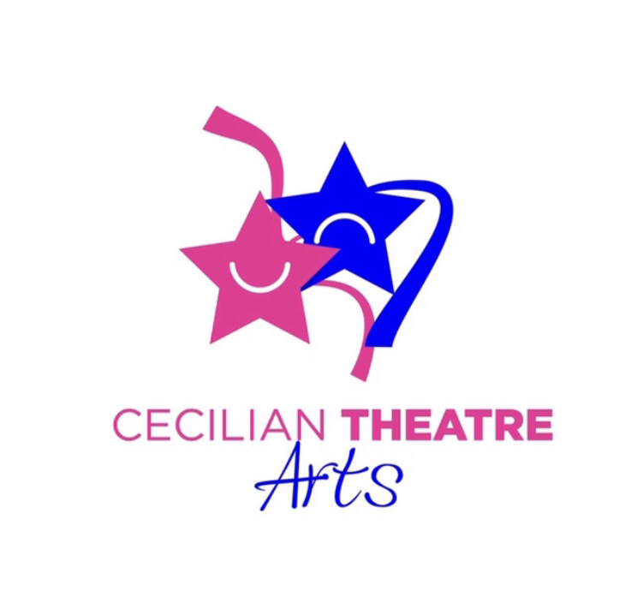
CECILIAN THEATRE ARTS & GDPR

Our Cookies & Privacy Policy

As a responsible and ethical business, we are committed to protecting your privacy.

Any personal information that you submit on our website will be stored securely and will not be shared with any other organisation for advertising purposes.

It is our policy fully to comply with the requirements of the General Data Protection Regulations, the Private and Electronic Communications Regulations (2003) and any other EU consumer legislation.

We collect the following information:

• Parents/Guardians Name

• Contact Phone/Email

• Demographic information such as your address, postcode

• Other information relevant to the student that you provide us with.

How We Use Your Personal Information:

The information supplied by you when you enrol your child in classes via this website will be stored by Cecilian Theatre Arts & will be used to process and update our records and to contact you with information about relevant products, services or opportunities that we believe might be of interest to you.

In order to keep you informed about relevant important school information or other events/opportunities we will communicate via text & email. You may opt out of receiving extra info outside of important messages, by emailing us to inform us.

Keeping Your Information Safe:

We are committed to ensuring that your information is secure. In order to prevent unauthorised access or disclosure, we have put in place suitable physical, electronic and managerial procedures to safeguard and secure the information we collect.

Links To Other Websites:

Our website may contain links to other websites of interest. However, once you have used these links to leave our site, you should note that we do not have any control over that other website. Therefore, we cannot be responsible for the protection and privacy of any information which you provide whilst visiting such sites and such sites are not governed by this privacy statement. You should exercise caution and look at the privacy statement applicable to the website in question.We include Facebook, Instagram & YouTube buttons on our pages which are also links. Use of these social media buttons are tracked.

Controlling Your Personal Information:

We will never pass your personal information to other organisations for them to market their services or products to you. You can choose not to receive further information about new classes, camps, workshops, by emailing us at info@ceciliantheatrearts.ie.

We will not pass your personal information to third parties unless we are required by law to do so.

If you believe that any information we are holding on you is incorrect or incomplete, please write to or email us as soon as possible, at the above address. We will promptly correct any information found to be incorrect. It is Parents/Guardians responsibility to ensure you update personal details with us if any such information changes.

COVID RELATED UPDATE

If necessary Cecilian Theatre Arts will forward contact details of Parent/Guardian to an authoritative body in the event of contact tracing.

UPDATED: JUNE 2020

